# Introduction to Digital Oscilloscope

Student name: Talha Tallat, Alessio Persechini

# 

## Theory

The purpose of this lab is to get you familiar with using the oscilloscope (scope for short). The oscilloscope is an instrument that measures electrical voltages which change with time. Oscilloscopes are indispensable tools for anyone designing, manufacturing or repairing electronic equipment. The only mathematics you need to know for this lab applies to the sine wave below

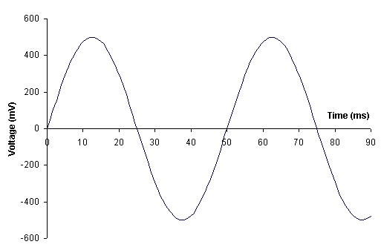

Peak to peak voltage Vpp

Period T

Peak voltage Vp



$V_{rms}=\frac{1}{\sqrt{2}} V_{peak}$

T=1/*f*

where is the sinusoid frequency and is its period.

# Procedure

1. Connect the output of Function Generator to CH1 input of Digital Oscilloscope
2. Select sine‒wave function in Function Generator.
3. Set the amplitude to any value in the range of 1 ‒ 10 V and frequency in the range of 1‒ 10 kHz.
4. Adjust the Vertical / Horizontal Scales and Trigger Level to get stable to get a stable picture of the waveform.
5. Sketch the waveform below using the Insert/Shapes/Curve tool.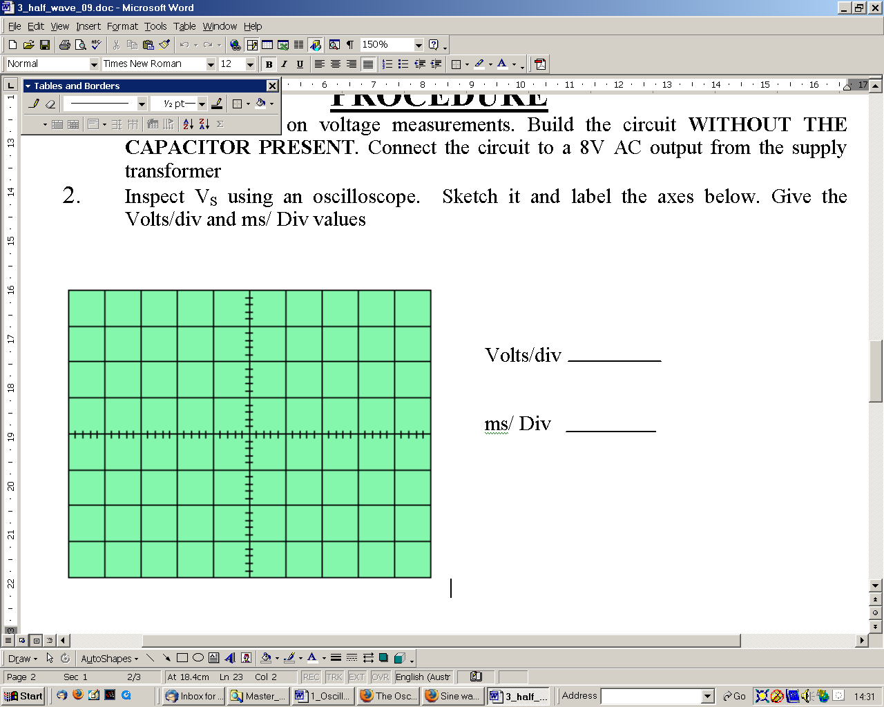

0.1ms

2.0V

1. Next, ground the vertical input by touching the red and black probes on the scope lead. Observe the horizontal line on the display screen. What happens? Write your answer below.

The Volts is = 0 as shown red line in fig. above.

1. Locate the controls listed in Table 1 below, and describe their effect on the display: Fill in Table 1 for the controls relevant to your oscilloscope, some may be absent.

|  |  |
| --- | --- |
| CONTROL | EFFECT |
| Horizontal Position | It Moves the sine wave left and right Horizontally. |
| Vertical Position | It moves the sine wave up and down vertically. |
| Horizontal Scale | It zooms in or out the sine wave horizontally to give you an accurate view of the wave. |
| Vertical Scale | It zooms in or out the sine wave vertically to give you an accurate view of the wave. |

Table 1. Oscilloscope controls

1. Measure the frequency of the sine wave by measuring its period on the oscilloscope screen and calculating the frequency.

Period T = 5div * 0.1ms/div

Frequency = 1/T = 2000Hz

1. Measure its peak amplitude accurately. What is its value?

Vp=6

1. **Calculate** the RMS value, from the measured peak value from the oscilloscope. Do your calculation here.

VRMS = Vp/√2= 6/√2 = 4.24V

1. Note that measuring the waveform period with the oscilloscope is a much more accurate measurement than reading the markings on the function generator frequency control knob. Without changing the output of the signal generator, **measure** the RMS voltage using a multimeter. How do the values from the multimeter and oscilloscope compare?

Vrms from DMM = 4.1V

Vrms from Scope = 4.66V

1. Use automatic measurements tool to measure the following parameters:

T= 505.6us , f= 1.979kHz , Vp‒p= 13.1V , +Vp= 6 , ‒Vp= -6.88V , Vrms= 4.66V , Vmean= -421mV,

1. Do the measured and calculated values for the rms Voltage match.? Tick a box

Yes

Yes

No

1. Write down below what happens if the trigger level is set too high.

The sine wave becomes unstable.

1. Write down below what happens if you change the trigger slope from positive to negative, if this facility is available on your scope.

It changes the slope negative or positive.

1. Write one comment on the work you have done.

We learned how to use a digital oscilloscope, we can get the values and measurements from it without using a multimeter. It is much easier to work with. Using the oscilloscope we can get all the values we needed in the questions such as RMS, Period, Frequency, Vp-p and voltage Mean.